Charles Morse

4669 Cumberland Rd.

Cumberland, BC V0R 1S0

Canada

[Charles.Morse@my.pacifica.edu](mailto:Charles.Morse@my.pacifica.edu)

604.831.3377

Engaged Shakespeare – HMC 280

Track X, First Year

Dr. Susan Rowland

May 1, 2019

**A MIDSUMMER'S MACDO ABOUT HAMLET: PART I**

**SHAKESPEARE'S TOOLS FOR SEEING BEYOND THE SURFACE**

Prospero: . . . We are such stuff as dreams are made on; and our little life is rounded with a sleep.

William Shakespeare, *The Tempest*, 4.1.156-158

My intent in creating the short animated film *A Midsummer's MacDo about Hamlet: Part I* was to imaginatively explore the archetypal qualities of Shakespearean characters that have stirred my imagination. Inspired by the work of Jungian scholar Susan Rowland and actress Kate Eastwood Norris, I used an arts-based research approach to engineer an archetypal petri dish of characters in the Boar's Head Inn of *King Henry IV parts I* and *II* fame. The exercise was indeed illuminating in this respect, but more significantly I became consciously aware of some of the techniques utilized by Shakespeare to reveal or suggest the deeper nature of things hidden behind appearances.

Archetypes and the collective unconscious are central innovations of C.G. Jung's analytical psychology. Whereas his onetime friend and mentor Sigmund Freud theorized that every individual has a personal unconscious containing repressed memories and impulses, Jung believed that the unconscious is much more than just a waste bin of repression and that there is a deeper layer of the psyche, the collective unconscious, which "contains allusions that go far beyond the personal sphere" (1966, p. 128). Jung's vision of the collective unconscious is like a vast, primordial stew of patterns and potentialities, and it is here that the archetypes originate. By archetype, Jung was referring to "formative principles in the unconscious that animate and condition our life experience" (Le Grice, 2017, p. 23).

Susan Rowland notes that, "Shakespeare is an archetypal author, in the sense that the archetypal images or symbols that make up his plays have a dynamic that is both personally and collectively relevant for the world we are in today" (2019). In choosing a dozen or so of Shakespeare's more archetypally-charged characters and allowing them to interact together in the well-lubricated environment of the Boar's Head Inn, I wanted to learn about the archetypes in the way that physicists learn about subatomic particles by prompting them to collide in a controlled environment. Like Greek gods and goddesses demonstrating their diverse and seemingly contradictory natures through their interactions with one another, archetypal patterns are revealed incrementally and through their relatedness.

As opposed to writing a script for the film, I first chose characters and imagined how they might interact with one another. I did this first through simple pen and watercolor drawings, which in itself proved to be a very valuable exercise in tapping into each character's archetypal essence. For example, in one image Ophelia calls to Hamlet and asks him to order her a drink. Her arched eyebrows and the motions of her arms indicate the uncertainty and timidity she feels in relationship with her moody, inscrutable lover. Hamlet, consumed by crippling indecision, slumps forward at the bar and holds one hand to his troubled brow, oblivious to Ophelia and lost in his own metaphorical thought bubble. Only after drawing all of the frames of the story did the characters' lines and the arc of the story begin to suggest themselves to me. In a very real sense, the characters "improvised" their lines.

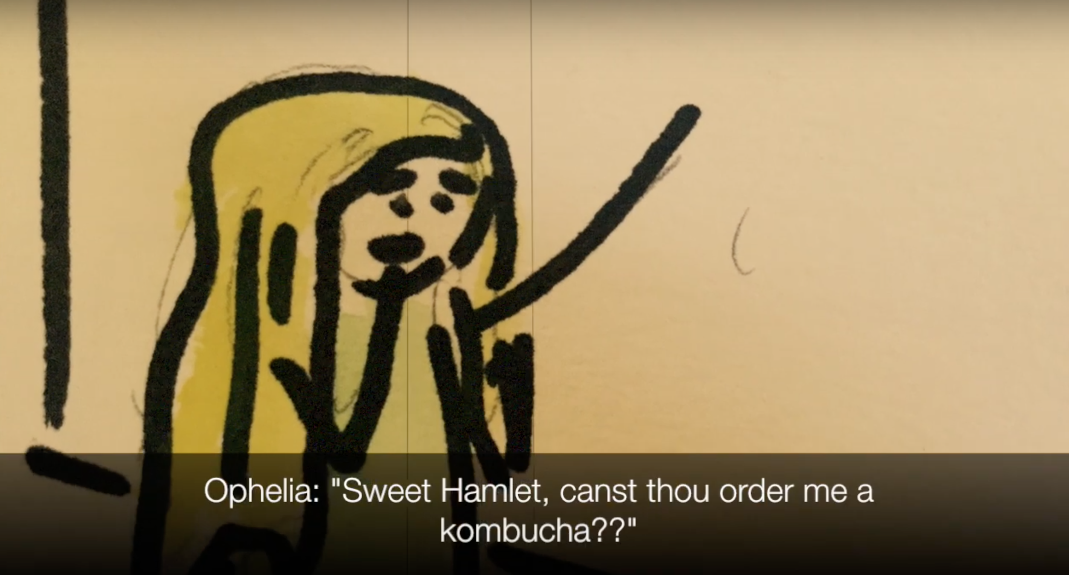 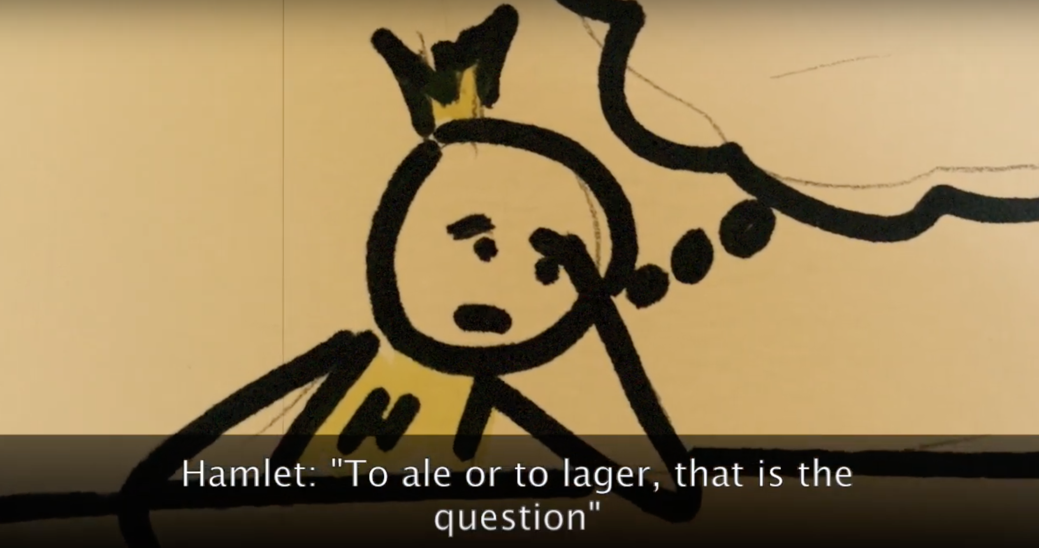

Almost invariably, Shakespeare's plays primarily involve the upper echelons of society. The Shakespearean canon is awash in dukes, thanes, kings, queens, lords, and ladies, members of a highly refined and cultivated class. To navigate this world and its rather rigid conventions, hierarchies, tastes, and expectations, this strata of characters make heavy use of their persona or personas. Taken from the ancient Greek word for the mask that actors wore onstage to inform the audience on the nature of their character, the persona is a "mask" we present to the world, the conscious interface between our ego and those we interact with. A world of persona is a world of appearances and half-truths, for each person develops a persona or personas, consciously or unconsciously, to highlight what is acceptable and conceal what is unacceptable within their particular milieu.

The enduring power of Shakespeare's work, however, lies in the playwright's extraordinary capacity to point to deeper truths behind appearances. Shakespeare had a full quiver of techniques by which he penetrated or even upended the apparent, seen world and hinted at more profound and mysterious forces at play. In Jungian terms, Shakespeare leads us past the conscious world of ego and persona and points to the collective unconscious realm of the archetypes. It was not until after I completed *A Midsummer's MacDo About Hamlet, Part I* that I realized I had unwittingly used many of these same techniques and devices to seed archetypal resonances. I will explore four of these techniques and examine how Shakespeare used them in his plays as well as how they manifested in my own short film.

**Magic**

In many of Shakespeare's most celebrated plays (*Hamlet, Macbeth, The Tempest, A Midsummer Night's Dream*), the drama of the play is set in motion by magic or by supernatural forces. *Hamlet* (1601) begins with a visitation from the slain King of Denmark who gives his son the terrible charge of avenging his death. The opening scene of *Macbeth* (1606) finds the title character conversing with witches who activate his (and later his wife's) latent insatiable ambition. Oberon and Titania, the fairy king and queen of A *Midsummer Night's Dream* (1595), drive the action of that play by enchanting the noble Athenians who stumble into their forest domain. Prospero, perhaps Shakespeare's most overtly magical protagonist, literally sets the stage for the play by causing a shipwreck in *The Tempest* (1611) and drawing the characters to his remote island.

In my short film, Oberon and Titania have gone from lords of the forest to lords of the public house. They maintain their penchant for enchantment, and Oberon encourages Titania to "be generous with thy elixir". This sets in motion all manner of unexpected couplings, a stirring of the archetypal stew. The witches, for their part, once again have Macbeth's number and goad him to evict a sleeping John Falstaff from his prime window table at the Boar's Head, setting in motion the central drama of the film (to the extent that a film of eight minutes can be said to have a central drama).

**Play within a play**

Throughout his work, Shakespeare frequently used the technique of the "play within a play" to expose concealed truths. In *Hamlet*, the prince cannot decisively grasp the full picture of his father's murder until enlisting a mendicant theater group to perform *The Murder of Gonzago*. It is Claudius' agitated response to the play that reveals to Hamlet the truth of his uncle's guilt.

Shakespeare also used this conceit to suggest that we are all very much like actors, our lives being directed or shaped in part by forces beyond our control and understanding. This idea is most famously articulated in Shakespeare's comedy *As You Like It* (1599)*:*

Jacques: All the world's a stage,

And all the men and women merely players.

They have their exits and their entrances,

And one man in his time plays many parts,

(2.7.139-142)

The performance of *Pyramus and Thisbe* as a play within a play in *A Midsummer Night's Dream* is a striking example of how Shakespeare uses this conceit to suggest to the audience that there are always hidden dimensions directing the action of our lives, for it is essentially a play within a play within a play. Through their magic and enchantments, Titania and Oberon are effectively writing and directing a play upon their own stage, the forest. Lines are blurred even further when Titania unsuspectingly goes from director to actor when she becomes enchanted herself and falls in love with the weaver, Nick Bottom.

My film envisions Shakespeare feverishly writing the first act of a new play after being inspired by dream images "delivered" to his psyche via his psychopomp Hermes from the Olympian office of Thalia and Melpomene, the Greek muses of comedy and tragedy. Yet just as Oberon's schemes go awry when Puck administers the love potion to the wrong character in *A* *Midsummer* *Night's Dream*, the plays envisioned by Thalia and Melpomene become hopelessly intermixed when Hermes drops the manuscripts entrusted to him. When the play commences in Boar's Head Inn, we are left to wonder, *who has written this*? Shakespeare? The muses? Charles? All or none of the above?

**The Fool**

It is often the simple or naive characters in Shakespeare that are uniquely capable of perceiving the truth hidden behind appearances. These characters have something of the archetype of the fool in them. Constable Dogberry and the members of his watch, the unlikely heroes of *Much Ado About Nothing* (1599), unmask the duplicity of the villain Don John and his associates. Dogberry appears to his wealthy, rational social superiors to be hopelessly inept and nonsensical, and in their first interaction the noble patriarch Count Leonato dismisses him curtly. In her article on Shakespeare's comedic constables, however, Shakespeare scholar Phoebe Spinrad notes "their very inefficiency is part of their effectuality, as well as another level of satiric commentary on the over-efficiency of even good enforcement systems" (Spinrad, 1992, p. 161). Shakespeare again seems to be saying that it is often an overestimation of our cultivated, rational, *conscious* selves that makes us dismissive and even blind to anything that is uncultivated, irrational, or unconscious.

Dogberry again plays the hero in my short film. He derails Macbeth's aggressive ambition to become "King of the Window Table" first by siting a simple parking violation, but in revealing that Great Birnham Twig has been "discomfitted" amongst Macbeth's possessions, Dogberry has discovered something obscure which was foretold by the witches. Later we fear that Dogberry's lack of sophistication may get the better of him, however, as the film concludes with a smitten and already plotting Lady Macbeth on his arm.

**Altered states of consciousness**

Using the term broadly, Shakespeare engineered a variety of ways for his characters to experience altered states of consciousness to discover or reveal hidden truths. Disguises, mistaken identities, and masked balls (as in *Much Ado About Nothing*) all serve to move the characters and the audience beyond and behind the world of appearances, although the journey is often a circuitous one. I have already discussed the enchantments of Oberon and Titania in *A Midsummer Night's Dream*, but more often than not a bit of tongue-loosening ale or sack (fortified wine) is sufficient for Shakespeare's characters to begin revealing hidden truths. Aptly named Borachio loquaciously divulges the details of Don John's plot in *Much Ado About Nothing*, and the sack-fueled banter at the Boar's Head Inn in the two *Henry IV* (1597, 1599) plays reveals, layer by layer, two of Shakespeare's most compelling and archetypal characters, John Falstaff and Prince Hal (soon to become Henry V).

I chose the Boar's Head for the setting of my film precisely because of the loosening of tongues and personas that the tavern facilitates. Taverns can be locations where people of all stripes and strata gather and comingle. Add the disinhibiting effects of alcohol and the amorous stirrings of fairy juice, and you can expect some very interesting archetypal interactions indeed.

Scholar of Jung and Shakespeare Matthew Fike writes, "Literature... is the product of a writer's response to the archetypes and, in turn, activates archetypes within the reader or theatrical audience" (Fike, 2009, p. 3). As a playwright, Shakespeare was unusually gifted in responding to archetypal patterns and symbols by bringing them into consciousness through his characters and plots. Even a lighthearted exercise of placing myself in the Bard's shoes (or night gown) provided me with a deeper understanding of how Shakespeare was able to consistently engage his audience with the archetypal content he drew up from the depths. Shakespeare was an endlessly inventive wordsmith, but he was equally inventive in the ways in which he could shift his audience's focus from the apparent to the obscure, from the manifest to the protean, and from the conscious to the unconscious.

References

Fike, M. (2009). *A Jungian study of Shakespeare: the visionary mode*. New York, NY: Palgrave Macmillan.

Jung, C. G. (1966). The personal and the collective unconscious. In R. F. C. Hull (Trans.), *The collected works of C. G. Jung* (Vol. 7, 2nd ed. pp. 127 - 155).Princeton, NJ: Princeton University Press. (Original work published 1953).

Le Grice, K. (2016). *Archetypal reflections: insights and ideas from Jungian psychology*. London, UK: Muswell Hill Press.

Rowland, S. (Speaker). (2019). *Engaged Shakespeare, lecture 5* (Digital Audio Recording)*.* Santa Barbara, CA: Pacifica Graduate Institute.

Shakespeare, W. (1998) *King Henry iv pt. 1, Richard III, Much ado about nothing, Hamlet, A midsummer night's dream, Macbeth, The tempest* and *As you like it* in *Shakespeare, complete works, the Arden Shakespeare*. Eds. Richard Proudfoot, Ann Thompson, and David Scott Kastan. New York, NY: Bloomsbury Arden Shakespeare.

Spinrad, P. (1992). Dogberry hero: Shakespeare's comic constables in their communal context. *Studies in philology.* 89(2), 161-178.